**Sheet 2**

1. Find the even and odd components of $x\left(t\right)=e^{jt}$**.**
2. Show that the product of two even signals or of two odd signals is an even signal and that the product of an even and an odd signal is an odd signal.
3. Sketch and label the even and odd components of the signals shown in Fig.

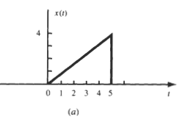

1. Show that:
2. If x(t) is even, then

$\int_{-a}^{a}{x\left(t\right)dt=2\int_{0}^{a}{x\left(t\right)dt}}$

1. If x(t) is odd, then

$\int_{-a}^{a}{x\left(t\right)dt=0}$

1. Determine whether the following signals are energy signals, power signals, or neither.
$x\left(t\right)=e^{-at} u\left(t\right) , a>0$

$x\left(t\right)=t u\left(t\right)$

2. Show that an exponential $e^{-at}$ starting at - ∞ is neither an energy nor a power signal for any real value of $a$. However, if $a$ is imaginary, it is a power signal with power P=1 regardless of the value of $a$.
3. Express the voltage waveform v(t) in Figure as a sum of unit step functions.

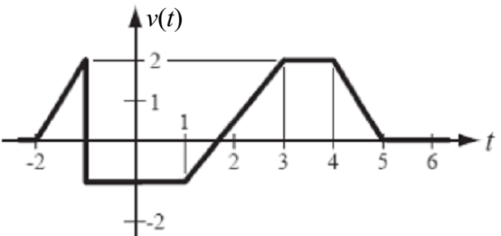

**Dr. Michael Nasief**

**Eng. Mohamed Elsayed**